Student’s name Teacher’s name

________________________________________ _____________________________



2019
Mathematics 5.2
End Semester 2 PRACTICE EXAMINATION

General Instructions  - Total working time –90 minutes  - Write using blue or black pen  Black pen is preferred  - Scientific calculators may be used | Total Marks – 100  - Questions arranged in topics. Attempt questions from all topics.

Section | 1 | 2 | 3 | 4 | Total
 | $$\frac{}{28}$$ | $$\frac{}{26}$$ | $$\frac{}{17}$$ | $$\frac{}{16}$$

Student Comment:

Teacher Comment:
PRACTICE EXAM
<Surface Area and Volume>
< 28 > marks
Attempt all Questions
Questions <1 to 4> Multiple choice
Allow about 20 minutes for this section

Circle the correct answer for Questions <1 to 4>

1. | If the area of a square field is 36km² the length of one side could be:
 | (A) 8km |  | (B) 6km |  | (C) 9km |  | (D) 18km
2. | The perimeter of this shape is:  2m  5m
 | (A) 7m |  | (B) 10m |  | (C) 15m |  | (D) 14m
3. | The volume of this rectangular prism is:  4m  3m  8m
 | (A) 136m² |  | (B) 96m² |  | (C) 15m² |  | (D) 68m²
4. | The volume of a cylinder with a radius 5cm and a height of 8cm is closest to:
 | (A) 40cm³ |  | (B) 126cm³ |  | (C) 628cm³ |  | (D) 314cm³
Questions <5-8> Short Answer. Show all working. Marks are as shown
5. | Convert the following to the units shown:
 |  |  |  |  |  |  |  |  |  |  | Marks
 | a. | 1120m = ____km |  |  |  |  |  |  |  |  | 1
 | b. | 14.3cm = _______mm |  |  |  |  |  |  |  |  | 1
 | c. | 1850${mm}^{2}$ = _____${cm}^{2}$ |  |  |  |  |  |  |  |  | 1
 | d. | 0.000032${2m}^{3}$ = _____${cm}^{3}$ |  |  |  |  |  |  |  |  | 1
6. | A teacher collects some blocks of wood for a classroom activity. Each block is a rectangular prism as shown.  6cm  5cm  14cm
 |  |  |  |  |  |  |  |  |  |  | Marks
 | a. | Find the volume of one block. |  |  |  |  |  |  |  |  | 1
 | b. | The blocks will be painted on all sides. Find the total surface area for one block in cm². |  |  |  |  |  |  |  |  | 3
 | c. | Paint costs $5.50 per 100cm². Find the cost of painting 12 blocks. |  |  |  |  |  |  |  |  | 2
 | d. | Calculate the volume and surface area of the following triangular prism:  b) Surface Area:  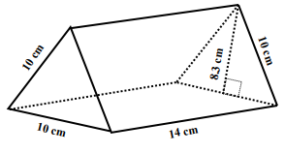  a) Volume:  Compare the volume and surface area of this block to the rectangular one above? |  |  |  |  |  |  |  |  | a) 2  b) 2  2
7. | Calculate the area of the following shapes: (to 2 decimal places)
 | a) Find the area of the Sector: |  |  |  |  |  |  |  |  | Marks
 | 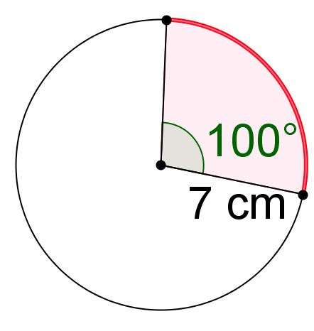 |  |  |  |  |  |  |  |  | 2
 | b) Determine the total area of this composite shape:
 | 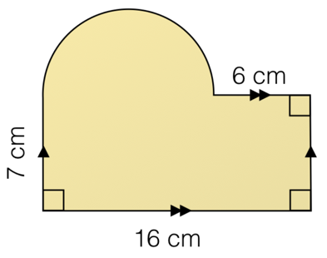 |  |  |  |  |  |  |  |  | 3
8.
 |  |  |  |  |  |  |  |  |  | Marks
 | How many litres of gas can a tanker carry if its tank is cylindrical with a diameter of 3m and is 12m in length? Round your answer to the nearest L. (1m³ = 1000L) |  |  |  |  |  |  |  |  | 3
<Indices>
< 26 > marks
Attempt all Questions
Questions <9 to 12> Multiple choice
Allow about 20 minutes for this section

Circle the correct answer for Questions <9 to 12>

9. | 3a⁵ × 5a³ =
 | (A) 15a¹⁵ |  | (B) 8a⁸ | (C) 15a⁸ |  | (D) 8a¹⁵
10. | 3(2m²)⁰
 | (A) 6 |  | (B) 3 | (C) 32m²⁰ |  | (D) 0
11. | (4a⁴)²
 | (A) 4a⁸ |  | (B) 16a⁶ | (C) 4a⁴² |  | (D) 16a⁸
12. | The mass of a shipping container is 4.53 × 10³ kg. This mass in kilograms is:
 | (A) 453000kg |  | (B) 4530kg | (C) 453kg |  | (D) 0.00453kg
Questions <13-15> Short Answer. Show all working. Marks are as shown

13.
 |  |  |  |  |  |  |  |  | Marks
 | a. | x³ × x⁴ = |  |  |  |  |  |  | 1
 | b. | (m⁴)⁵ = |  |  |  |  |  |  | 1
 | c. | Write with positive indices:  m⁻⁵ = |  |  |  |  |  |  | 1
14.
 |  |  |  |  |  |  |  |  | Marks
 | a. | 2a⁴ b³ c × 7a³b = |  |  |  |  |  |  | 2
 | b. | x⁹ y⁷ ÷ (x³ y)² = |  |  |  |  |  |  | 2
 | c. | $\frac{8a^{5}b^{6}}{{2a}^{2}b}$ = |  |  |  |  |  |  | 2
 | d. | $\frac{4m^{3}n^{6}}{16m^{7}np}$ = |  |  |  |  |  |  | 3
 | e. | (2a⁵)⁶ = |  |  |  |  |  |  | 2
 | f. | Solve and write with positive indices:  (3 a³b⁻²)⁻²$×$ 2a² |  |  |  |  |  |  | 3
15.
 |  |  |  |  |  |  |  | Marks
 | Convert the following to scientific notation:  a) 342000000 b) 0.000347 |  |  |  |  |  |  | 2
 | Calculate the number of hours in 3 years. (no leap years)  Write your answer using scientific notation, correct to 3 significant figures. |  |  |  |  |  |  | 3
<Right Angled Triangles>
<17> marks
Attempt all Questions
Questions <16 to 19> Multiple choice
Allow about 15 minutes for this section
Circle the correct answer for Questions <16 to 19>

16. | Which side is the Hypotenuse:  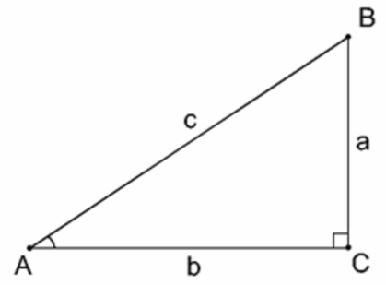
 | (A) a |  | (B) b | (C) c |  | (D) There is no Hypotenuse
17. | Which fraction is equal to Tan( t ):  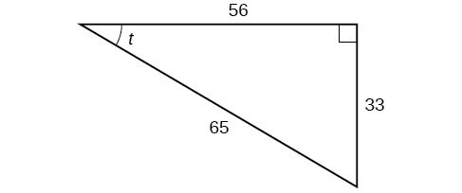
 | (A) $\frac{56}{65}$ |  | (B) $\frac{33}{65}$ | (C) $\frac{56}{33}$ |  | (D) $\frac{33}{56}$
18. | Which equation represents Pythagoras’ Theorem for the following Triangle:  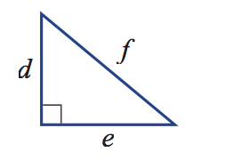
 | (A) $f^{2}= \sqrt{d^{2}+e^{2}}$ |  | (B)$f$ = $\sqrt{d^{2}-e^{2}}$ | (C) $f^{2}$= $d^{2}{- e}^{2}$ |  | (D)$f= \sqrt{d^{2}+e^{2}}$
19. | Find the value of $θ$, if cos$θ=0.5$
 | (A) 60$°$ |  | (B) 30$°$ | (C) 90$°$ |  | (D) 45$°$
Questions <20-22> Short Answer. Show all working. Marks are as shown

20.
 |  |  |  |  |  |  |  |  | Marks
 | a. | Calculate the length of the side ‘z’:  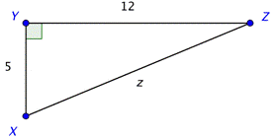 |  |  |  |  |  |  | 2
 | b. | Find the value of the pronumeral, a:  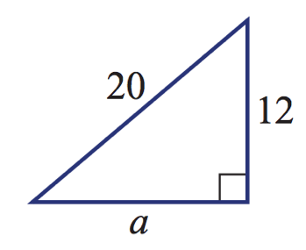 |  |  |  |  |  |  | 2
21.
 |  |  |  |  |  |  |  |  | Marks
 | a. | Find the value of y and g, correct to 2 decimal places:  sin 30$°$ = $\frac{y}{4}$ cos 30$°$ = $\frac{5}{g}$ |  |  |  |  |  |  | 2
 | b. | Calculate the value of the pronumeral, x:  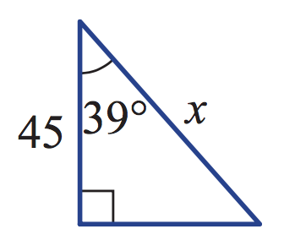 |  |  |  |  |  |  | 2
 | c. | Determine the value of the pronumeral, x:  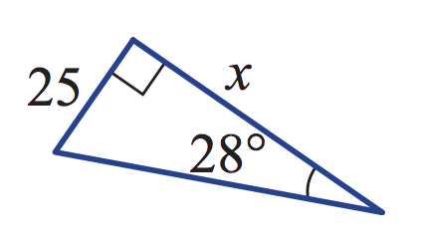 |  |  |  |  |  |  | 2
22.
 |  |  |  |  |  |  |  | Marks
 | From a point on the ground, Sergei measures the angle of elevation of an 80m tower to be 27$°$.  i) Draw a diagram to represent this information.  ii) Find how far Sergei is from the base of the tower, correct to the nearest metre. |  |  |  |  |  |  | 3

<Linear Relationships>
<16> marks
Attempt all Questions
Questions < 23 to 26> Multiple choice
Allow about 15 minutes for this section

Circle the correct answer for Questions <23 to 26>

23. | The line $y=3x – 2$ has a y-intercept of:
 | (A) b = -2 |  | (B) b = 2 | (C) b = -3 | (D) b = 3
24. | Determine the gradient of the following line:  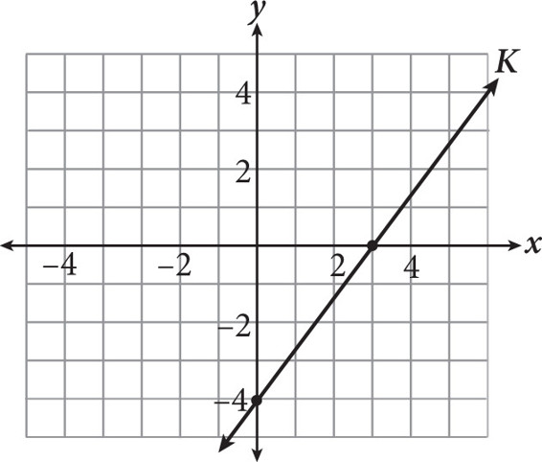
 | (A) m = $-\frac{3}{4}$ |  | (B) m = $\frac{3}{4}$ | (C) m = $\frac{4}{3}$ | (D) m = $-\frac{4}{3}$
25. | For the line $y=2x+3$, the value of y when x = 2 is:
 | (A) y = 5 |  | (B) y = 25 | (C) y = 1 | (D) y = 7
26. | What is the equation of the line below:  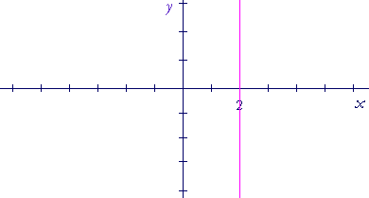
 | (A) x = 2 |  | (B) y = 2x | (C) y = x + 2 | (D) y = 2
Questions <27 and 28 > Short Answer. Show all working. Marks are as shown

27.
 |  |  |  |  |  | Marks
 | a. | Plot the point, A, at (-2,-4) on the plane below:  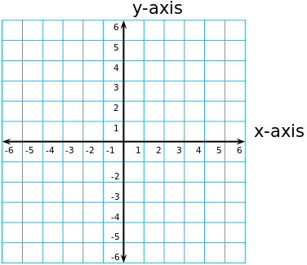 |  |  |  | 1
 | b. | Plot a point, B, in the first quadrant above and state the co-ordinates of point B. Calculate the distance between point A and point B. |  |  |  | 3
 | c. | Calculate the midpoint between points A and B: |  |  |  | 2
 | d. | Determine the gradient of the line joining point A and B:  Determine the y-intercept of the line joining point A and B:  State the equation of the line which connects points A and B: |  |  |  | 1  1  1
28.
 |  |  |  |  |  | Marks
 | a. | Plot the following line by finding the x and y intercepts: $y=-2x+4$   |  |  |  | 3

END OF EXAM

